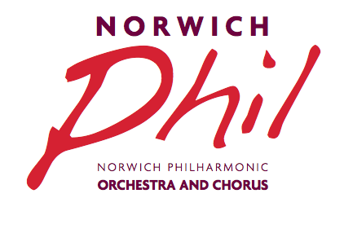 Registered Charity No.264425
The Annual General Meeting will be held in the Music Room, The Assembly House, Norwich on Wednesday 20 June 2018 at 7.30pm. A bar for refreshments will be open from 7pm.

AGENDA
- Apologies for absence
- Minutes of the last AGM
- To receive the Chairman’s Report
- To receive and approve the Accounts (copies of the Financial Report for 1 May 2017 to 30 April 2018 will be available to read online on the website www.norwichphil.org.uk from Monday 18 June or as a hard copy from 7pm in the Music Room)
- Election of Officers
Present Officers seeking re-election are:
Secretary Sue Mitchell
Assistant Secretary Elaine Shaw
Treasurer Kate Anetts
Front of House Manager Sue Prutton
Chorus Secretary Sally West-Lindell
Orchestra Secretary Rob Barnes
Secretary to the Friends and Benefactors Kate Anetts
Orchestra Subcommittee Chairman Michael Nutt
Orchestra Librarian Caroline Furniss

The roles of Chairman and Vice Chairman are not up for election as these are three year appointments from June 2016.

- Election of Ordinary Members*
There are currently no vacancies for Orchestral or Choral Representatives on the Committee. Alison Corfield has agreed to serve as a Public Representative on behalf of Norfolk Music Services replacing Juliet Rickard who is standing down. Gillian Shaw has agreed to serve as her deputy. There remains a further vacancy for a Public Representative for which nominations are invited. In accordance with the Society’s Constitution, if there are insufficient nominations by the closing date, the Chairman may exercise her discretion to invite further nominations.

- Appointment of an Independent Accounts Examiner
8. Presentation of Long Service Awards to Members
9. Concert Programme for the next season 2018/9
10. Any other business
Sue Mitchell (NPS Secretary)
Following the AGM, we welcome Members of the Norfolk Centre for Young Musicians who will be providing musical entertainment.

*Nominations should be sent to Sue Mitchell, Norwich Philharmonic Society Secretary, 19 Branksome Close, Norwich, NR4 6SP or by email to philsec@norwichphil.org.uk to arrive no later than Wednesday 30 May 2018 (the closing date).

NOMINATION FORM

We, being members of the Society, hereby nominate…………………………………………………………. (block capitals)

To serve as……………………………………………………………………………………………………….

Proposer’s name……………………………………………. Signature……………………………………….

Seconder’s name…………………………………………… Signature………………………………………..

Nominee’s signature…………………………………………… Date………………………………………….

