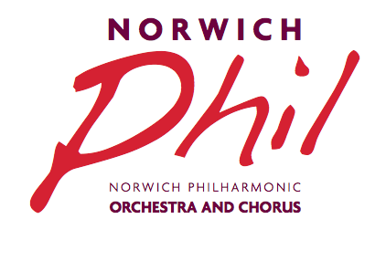 Registered Charity No.264425
The Annual General Meeting will be held in the Music Room, The Assembly House, Norwich on Tuesday 18 June 2019 at 7.30pm. A bar for refreshments will be open from 7pm.

AGENDA

Apologies for absence
- Minutes of the last AGM
- To receive the Chairman’s Report
- To receive and approve the Accounts (copies of the Financial Report for 1 May 2018 to 30 April 2019 will be available to read online on the website www.norwichphil.org.uk from Monday 17 June or as a hard copy from 7pm in the Music Room)
- Proposed Amendments to the Constitution
Notice is hereby given of an amendment to the Constitution proposed by the Committee for a vote to be taken by members at the AGM as follows: Clause 5 ‘Officers’ to be amended by removing the role of Assistant Secretary and adding the role of Publicity Officer.

- Election of Officers *
Present Officers seeking re-election are:
Chairman Caroline Dixey
Vice Chairman
Secretary Sue Mitchell
Treasurer Kate Anetts
Front of House Manager Sue Prutton
Chorus Secretary Sally West-Lindell
Orchestra Secretary Rob Barnes
Secretary to the Friends and Benefactors Kate Anetts
Orchestra Subcommittee Chairman Michael Nutt
Publicity Officer
The roles of Chairman and Vice Chairman are up for election as these are three-year appointments from June 2016. Under the Society’s constitution the Chairman and Vice Chairman must have already served on the Committee and should only be re-elected if there are no other nominations. The role of Vice Chairman is vacant and a nomination has been received for Michael Nutt. There is a new role of Publicity Officer for which nominations are invited. More details of the role will be included shortly in the members’ Newsletter.

- Election of Ordinary Members*
There is a vacancy for one Orchestra Representative for which a nomination has been received for Judy Tryggvason and a vacancy for one Chorus Representative for which a nomination has been received for Frances Beadle. There are vacancies for two Public Representatives for which nominations are invited.

8. Appointment of an Independent Accounts Examiner
9. Concert Programme for the next season 2019/20
10. Future Plans for the Chorus (DD)
11. Any other business Sue Mitchell (NPS Secretary)
Following the AGM, we will be entertained by talented young players from the Norfolk Centre for Young Musicians. Please do come and give them your support.

*Nominations should be sent to:
Mrs Sue Mitchell, Norwich Philharmonic Society Secretary,
19 Branksome Close, Norwich, NR4 6SP
to arrive no later than Tuesday 4 June 2019 (the closing date).

NOMINATION FORM

We, being members of the Society, hereby nominate

……………………………………………………………………………………………….. (block capitals)

To serve as…………………………………………………………………………………….

Proposer’s name………………………………….. Signature…………………………….

Seconder’s name………………………………….. Signature…………………………,,,,,

Nominee’s signature………………………………. Date…………………………………

