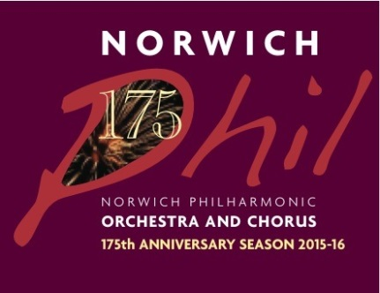
Norwich Philharmonic Society’s 175th Anniversary performance of Mahler’s 8th Symphony
Norfolk Showground Arena, 21st May 2016:

Information for performers

Many thanks for taking part in what is almost certainly the biggest event in the long and illustrious history of the Norwich Phil! We thought it would be useful to give you some information about the arrangements for the final week of rehearsals and performance and what to expect on the day.

Schedule overview
Tues 17th May 7.15pm Rehearsal at the Showground Arena – Tutti orchestra and Norwich Phil Chorus (members of KLFC and SCCS also very welcome to attend if able)
Wed 18th-Thu 19th May Stage Build and Arena fit-out
Fri 20th May 7pm Rehearsal at the Arena – Tutti orchestra, all choirs and soloists.
Sat 21st May 1pm Rehearsal at the Arena – Tutti orchestra, all choirs and soloists.
Sat 21st May 8pm Performance
Sun 22nd-Mon 23rd May Staging and seating etc removed

Tuesday 17th May
7.15pm to approx 9.45pm Rehearsal at the Showground Arena. Tutti orchestra and Norwich Phil Chorus (members of KLFC and SCCS also very welcome to attend if able).

Please arrive well in time for start of rehearsal to help set up chairs for both orchestra and choirs.
Orchestra – Please bring music stands.

Please note that the rehearsal will take place on the flat floor (with no stage or audience seating installed) - so be prepared for a rather reverberant acoustic!

Entrance to site via main gates off roundabout. Ample parking for performers on site as marked on site plan below.

Refreshments - Fruit juice and biscuits will be offered during the rehearsal break on Tuesday.

Friday 20th May
The stage will be finished by noon on Friday and audience seats will be laid out during the day (CALL FOR VOLUNTEERS – we would welcome anyone who is available during the day on Friday to help set out and number 2,000 plus seats!).

7pm to approx 10pm Rehearsal at the Arena (NB note earlier start time!). Tutti orchestra, all choirs and soloists.

Please arrive well in time for start of rehearsal - no later than 6.30pm please - as there will be a great deal of sorting out of places and positions on stage and in the choir stalls.

Orchestra – music stands will be provided (our own stands and matching stands from NCMS will be delivered by van to site during the afternoon).

Access to site and parking as above.

Refreshments – Please bring your own for the rehearsal break on Friday.

Saturday 21st May
1pm to 4pm Rehearsal at the Arena. Tutti orchestra, all choirs and soloists. Please arrive well in time - no later than 12.30pm please.

4pm to approx 4.30pm Choirs rehearse line-ups in the annex behind the stage area and going on stage in the correct order to the right seats.

4pm onwards On-site catering outlets in operation (see below for info about food and drink facilities on and off site))

We have a good rest period between rehearsal and performance but we would discourage performers leaving the site because of likely traffic congestion to the Showground before the concert. If you do need to leave the site you MUST be back no later than one hour before start of the concert.

We have the use of three Span Buildings (adjoining the back stage area of the Arena) as Green Rooms where tables and chairs will be set out and where instrument cases, performance clothes etc can be left. One of these buildings will be for exclusive use of the children’s choir. However you are advised not to bring valuables to the show ground and, in particular, not into the Green Rooms. We suggest you lock any possessions of value you need to bring with you securely in your car. The Span Buildings will be locked during the performance.

Please be aware that there will be no facilities for hanging clothing in the Green Rooms adjacent to the Arena.

Soloists and conductor’s dressing rooms are in the Macgregor Building. One room for ladies, one for men and one for conductor and Catherine May. Transport will be provided to the backstage area before the concert.

Access to site and parking as above. It is important that you use the designated Performers’ Parking area which is separate to audience parking.

Concert dress:
Ladies – all black
Men – Dinner jackets

A VIP reception is being organised by the Royal Norfolk Agricultural Association before the concert with drinks and canapés served in the VIP marquee at St. Walstan Hall from 6.45pm.

Performers’ calls:
Our stage managers, John and Katherine Gray and assistant, Julian Walker, will give calls at 30 minutes, 15 minutes and 10 minutes, and a final call to assemble everyone in line to proceed to the stage. The soloists and the conductor will receive separate calls from John's team in their dressing rooms in the MacGregor Building (and will be transported to back stage by courtesy car).

8pm Scheduled start time (although this may in practice e be delayed if audience are late getting on to site as there is no admission for late-comers).

9.30pm Estimated finish time

After performance:
Choir – all choir members will be asked to assist with removing their chairs and placing them in a designated area behind the stage. N Phil music folders and scores to storage crate and music box in the green room. KLFC and SCCS scores to respective choir librarians.
Orchestra – volunteers required to help fold and move chairs and music stands. Music to be returned to orchestra librarian Caroline Furniss in Green Room.

Stands, music folders and celeste to be loaded into van for return to St Andrew’s Hall.

Post-concert bar for performers and their friends in St Walstan’s Hall after the performance. Please join us for a celebratory drink after the performance while the Showground empties of audience cars.

Sunday 22nd May and Monday 23rd May
The stage will be dismantled on Sunday and seats and various equipment taken away on Monday.
VOLUNTEERS REQUIRED PLEASE on Sunday to help fold and stack seats ready for collection on Monday.

General Information

Venue
Norfolk Showground Arena, Dereham Road, Norwich NR5 0TT

Directions
The Norfolk Showground is located on the A47 west of Norwich. Postcode for Sat Nav: NR5 0TP.

From the North and West – situated just off the A47 Norwich Southern Bypass at the A1074 Longwater Interchange.

From the South and East – Travelling to Norwich via the A11 or A140 from Ipswich, take the A47 westbound and follow the signs for Norfolk Showground.

The Arena and performers’ parking will be signposted once you are in the Showground.

Parking
A designated parking area has been allocated to all performers which will be signposted from the main entrance. See site plan below.

Site Plan
See next page.

Toilets
These are situated in the atrium of the Arena itself; in the external toilet block just outside the entrance to the Arena; and in St Walstan’s Hall, the latter the nearest to the backstage area and green rooms in the Span Buildings.

Food and refreshments
Fruit juice and biscuits will be offered during the rehearsal breaks on Tuesday only. Because of the large numbers of people involved we would ask you please to bring your own refreshments on Friday.

On concert day there will be food available from 4pm from a number of food stalls on site (see below). However, owing to the number of performers, you may wish to bring your own hot drinks and food to avoid delays.

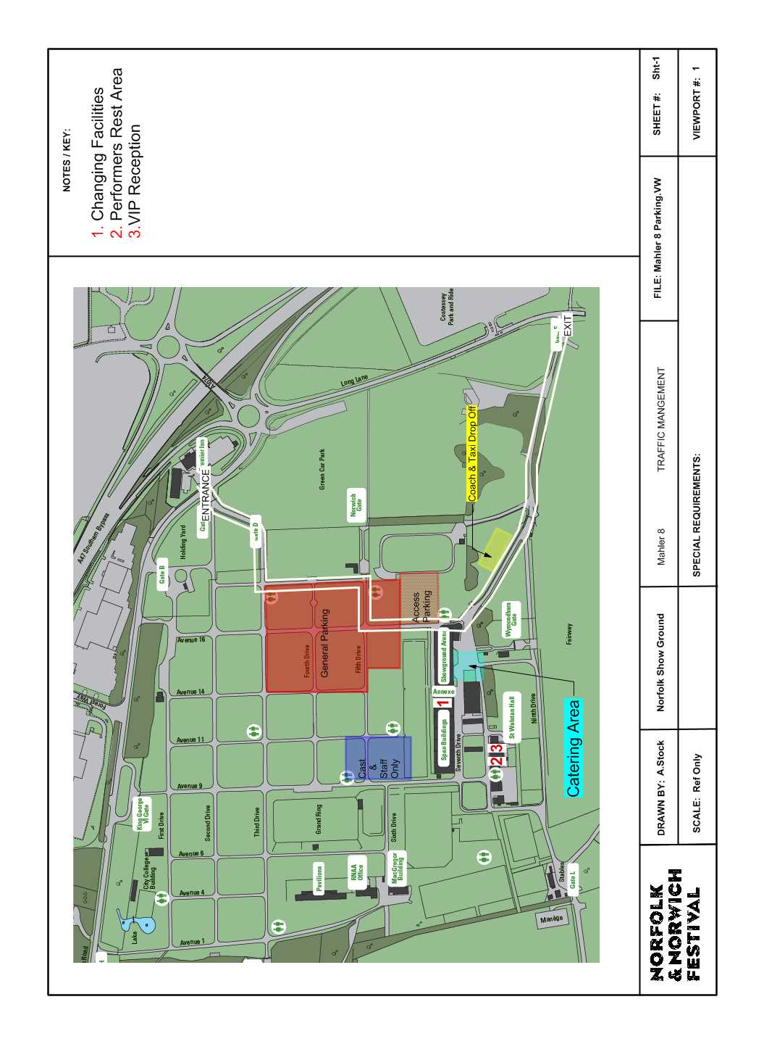

On site:
The RNAA has engaged Feast on the Street (a street food collective and non-profit making group) to provide the following street food traders who will be trading from 4pm until about 7.30pm on the hardstanding outside the Arena:
Proper Pizza Co - pizza with a choice of toppings cooked on a real wood fire
The Duck Truck - duck wraps with cucumber, spring onion and hoisin sauce
Mr T's Catering - slow cooked pulled pork with 'slaw & BBQ sauce, plus locally sourced beef burgers
The Waffle Works - waffles with assorted toppings on a stick
Pickle-O Coffee - serving craft, local Grey Seal coffee
The Nags Head - a bar in a horsebox serving a range of beers, lager and wine.

Off site:
The nearest restaurant is Table Table at the Premier Inn, just opposite the main entrance to the Showground.
On the Longwater retail park on the other side of the A47 junction there are eating places in some of the large stores – Next Superstore (Costa), Sainsburys and The Range – and also The Cooper Beech pub.
The King’s Head at Bawburgh will be serving pre-concert suppers from 5.30pm – from £20 for 2 courses.

Security
Although we have a backstage team, there is no dedicated security on site either during rehearsals or concert. You are advised not to bring valuables to the Showground and, in particular, not into the Green Rooms. We suggest you lock any possessions of value you need to bring with you securely in your car.

Concert programmes
Souvenir copies of the concert programme will be available for all performers at half price. Please note these will only be available at the Saturday rehearsal so if you want one make sure you buy yours then. (Programmes at the reduced price for performers are NOT available from the programme sellers.)

Publicity and ticket sales
As you will be aware tickets have sold very well for the concert but please do continue to plug the concert to all your friends and family. Let us know if you wat any leaflets and do use the attached e-flyer to email to you contacts or post on Facebook It would be great to have a completely full house of 2,222!

If you require any tickets we recommend you contact the Theatre Royal Box Office as soon as possible. Any unsold tickets will also be available in the night.

Tickets: £28, £24, £18, £12
From Theatre Royal Norwich Box Office, Theatre Street, Norwich NR2 1RL
Tel. 01603 766400
www.nnfestival.org.uk
Concessions – 10% off (except top price seats) Under 25s – limited number of seats available at £7.50 (excluding top price)

Feedback
As part of the Arts Council’s requirements for its Grants For the Arts funding for the event, we will be producing an evaluation report. Please feel free to send us any comments about your experience of taking part in the performance and what you thought about the project as a whole.

Please email these to: michaelnutt@btconnect.com

